**REPORT**

**Overview:**

In this report, we have developed an Object model which help us in measuring the performance and quality of education of Universities which they provide to the students by considering various factors and entities.

Also sequence diagrams are provided for getting the course and faculty rankings, Alumni details and steps for creating, modifying or deleting course contents.

At the end, with the help of feedback from the Alumni, faculty rankings and course rankings we have derived dashboards for various scenarios.

**Proposed Object Model:**

The object model that we have proposed involves various entities such as university, college, department, course, student, alumni etc. which is displayed on the next page. Using transcripts, we can track the academic performance of the student and the courses he has opted for. After the graduation, the data related to the students – salary, job profile, promotion details etc. are all stored in a common database for the administrator to access and gauge various trends.

All the entities of the model are explained briefly-

**University**-

University is responsible for all the academic offerings which includes the synergy of the following components- College and its courses, Students and its various attributes, teachers and its course offerings and much more. University also looks into the business matters such as staff, faculty for the smooth operations of the model.

**College**-

College is responsible for all the specific academic offerings that it has to offer. It consists of various departments that offers different field of studies.

**Department**-

Department offers various courses. Department is responsible for designing, maintaining, and smooth operations of its offering. Student choose various courses that align to their field of interest. Department is also directly responsible for the delivery of the process- how its services and product will be delivered to its customers.

It also designs and maintains a way of evaluation of the performance of its components namely- students, courses, etc.

**Course Catalog**-

It models a list of all the courses that are being offered by the college or department in a University. Course offering is time bounded – it has a specific start and end date. Course Catalog also has a teacher and details of the classroom in which the course is being held.

**Course**-

Course consists of the details for that course. It exists in that particular course catalog only. It also includes the details of the independent teachers that are working for that course.

**Degree**-

Degree is the specialization of the student that he chooses to study. Degree contains the details of the courses offered by the department in each academic session – i.e. from first semester to the last semester.

**Faculty**-

Faulty members are the teachers of the courses. Faculty members can be further distinguished by their seniority namely professor, assistant professor, dean, etc. Faculty member teach courses to the student. They are also responsible for the grading of the subject for a student.

**Students**-

Students are the customers of the University. They enroll into a specific program that they want to build their career in.

A student reviews the course offered by the department of the college of that particular university applies for that and if selected pursues his or her further education in that course offerings by registering for the classes. They are also responsible for the review of the teacher based on their teachings.

**Alumni**-

An alumni is a student who have successfully completed his/her course offered by the university according to the graduation requirements. University model also maintains the alumni’s details such as his job profile, any promotions, his opted courses, teacher under which he learned the course, grades, etc.

**Transcripts**-

Transcripts are the document issued by the university which contains the information of the student’s academic process. Transcripts has details of the students details such as his course work, how much he was scored from his first semester to the last semester.

**Object Model-**



*Figure 1: Object Model*

**Proposed Solution for Course and Faculty feedback:**

The following is the proposed solution to evaluate the performance of course and faculty. A high level view of data flow is given below-

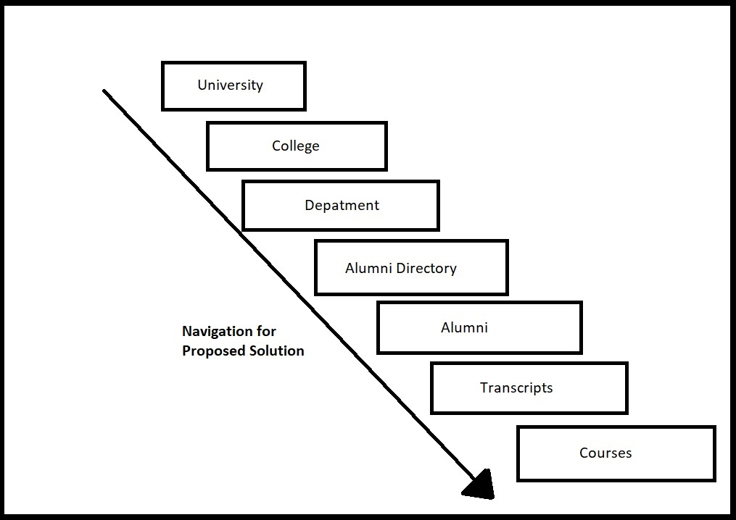

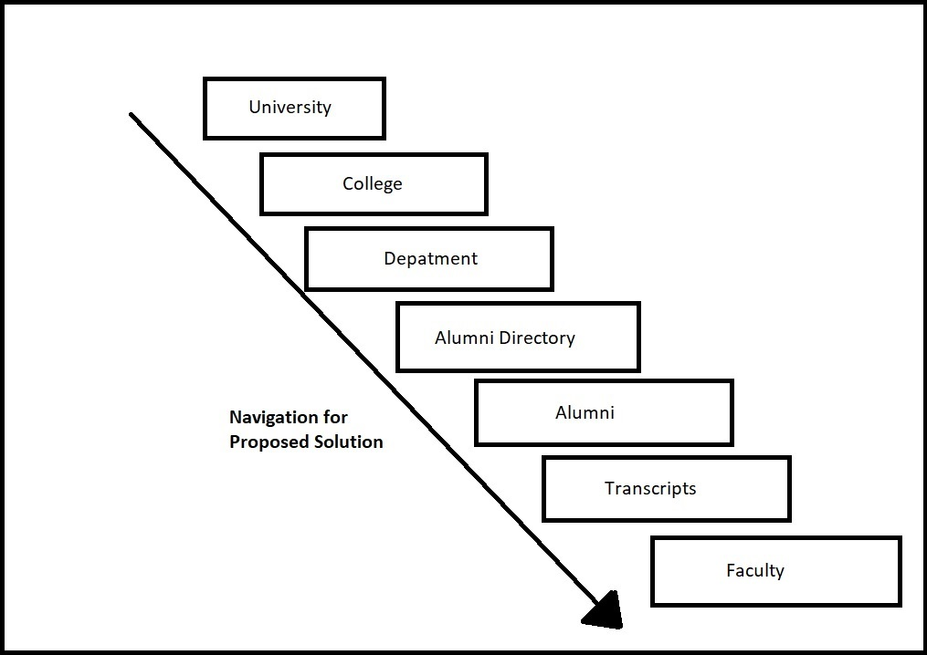

(Figure 2)

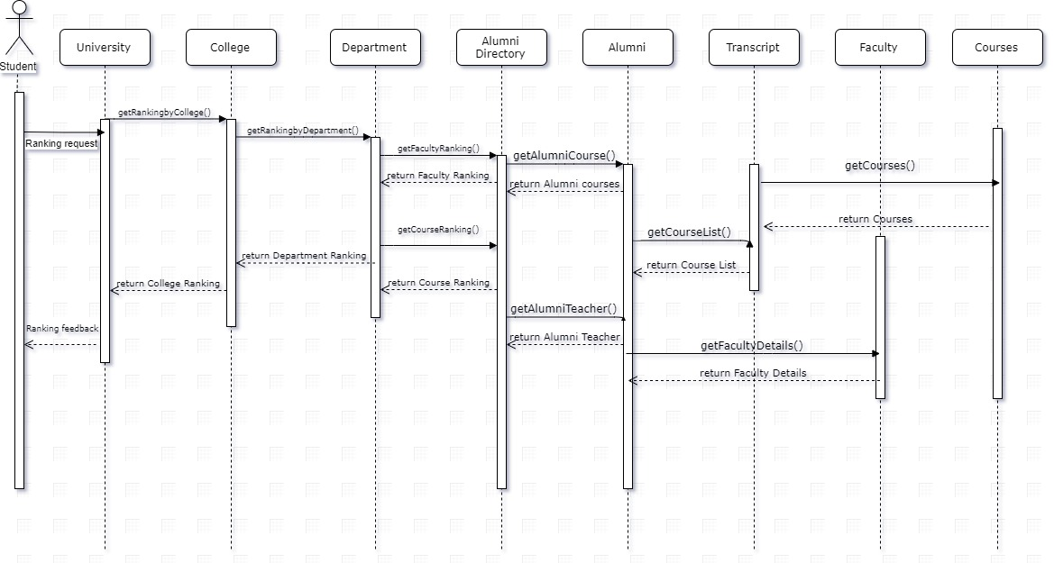

Figure 3

In the above figure, we have tried to showcase our proposed solution for course and faculty feedback using a sequence diagram. We try to figure out sequence that will help us to evaluate the course and faculty.

The evaluation of courses depends upon the alumni’s grade in that course and how useful that course was for him in his career. The evaluation of courses also depends upon the alumni ratings and their feedback for the given courses.

We can easily track the name of the courses that the student (Now- alumni) had opted for during his studies, using his transcripts. Using that information, we can get the names of the faculty that have taught the course. The extracted information will go into the alumni class. By getting the student’s rating for the faculty, we can evaluate the performance of the faculty. This is how we can evaluate the performance of the faculty.

**Proposed Solution for Alumni Performance**

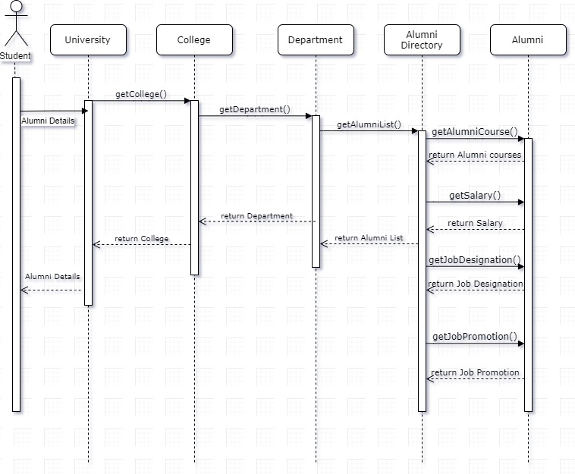

Figure 4

In figure 4, we have tried to showcase our proposed solution for alumni details using a sequence diagram in that, we try to figure out sequence that will help us to evaluate the performances of the alumni in their respective fields.

Firstly, we get the list of courses that the student (Now- alumni) had opted for during his studies, which can be easily tracked from his transcript class. This goes into the alumni class. Then, the alumni class has attributes such as Job position, Salary, Promotion Interval. Using that we can take the feedback from the alumni. Using this feedback from the alumni attributes we can get the ranking for the various courses and departments.

**Proposed Solution for Course modification-**

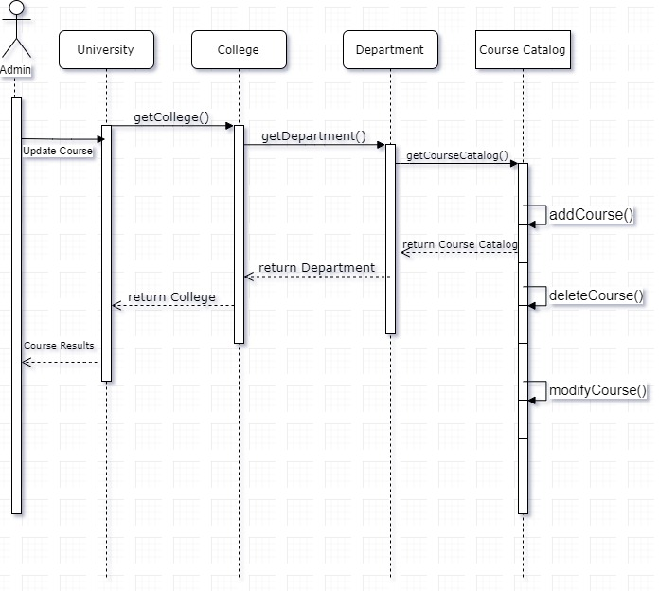

Figure 5

In figure 5, we have tried to showcase our proposed solution for course modification using a sequence diagram in that, we try to figure out sequence that will help us to evaluate the get the feedback of the course and have an option to modify it.

Depending on the review of the course from alumni, current students we have the option of modifying or deleting the whole course. In case, there is a demand of certain course which need needs to be included in the course catalog, using same method we can add a relevant course to the department. We extract the list of courses that we want to modify or delete. We can do that by using the course catalog under the departmental section.

This is how we can add, modify or even delete the course from the course catalog.

**Dashboard to show output of the obtained data-**

With the above solution, the college and administrative department can get all the data related to courses and faculty with the help of the feedback from Alumni students. To compare the results of the feedback, a dashboard with different charts can be used to interpret the results of the feedback taken. With the help of all these data, the college administration can take necessary steps to make their system better.

The above chart shows the average ratings of different departments to analyze the performances of faculty and the courses taught by them.

The chart shows the courses taken by Alumni Students which helped them in their respective fields. This can help other students to decide which courses to take with the help of the feedback given by former students.

A chart to show the growth of Alumni Students for different departments according to the average annual salaries earned for the past 5 years.

A chart to show percentage of students recruited by different companies.